Part Name | CTCXXXX | CTDXXXX | CTFXXXX | CTGXXXX-S | CTGXXXX-F
Out line | 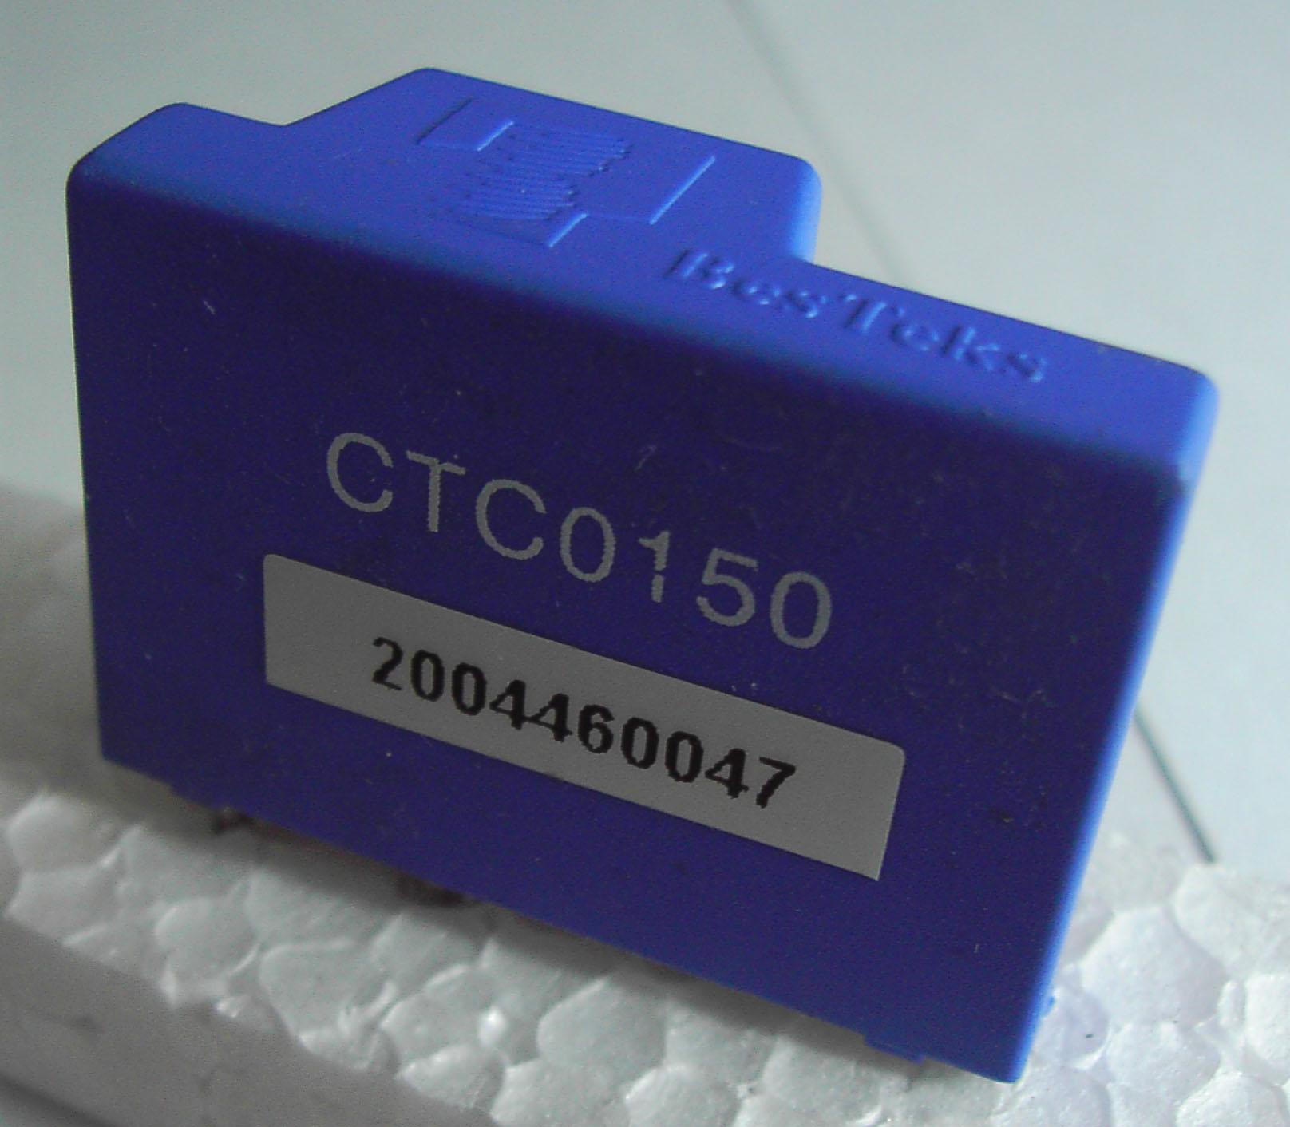 | 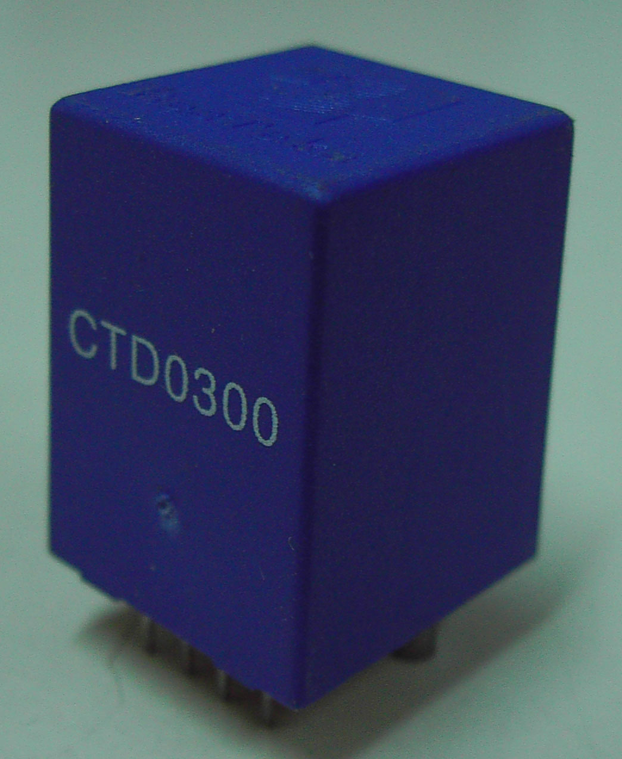 | 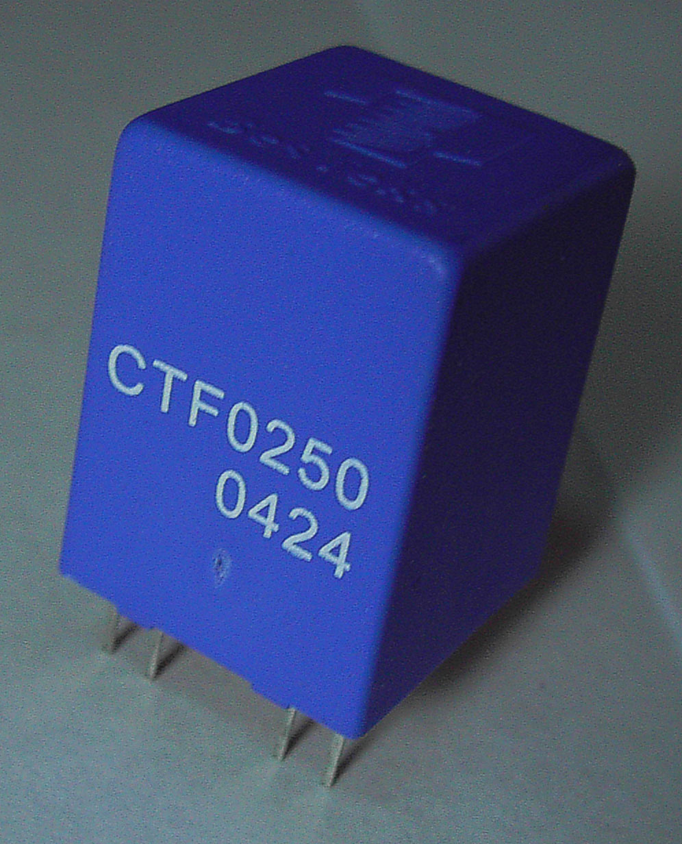 | 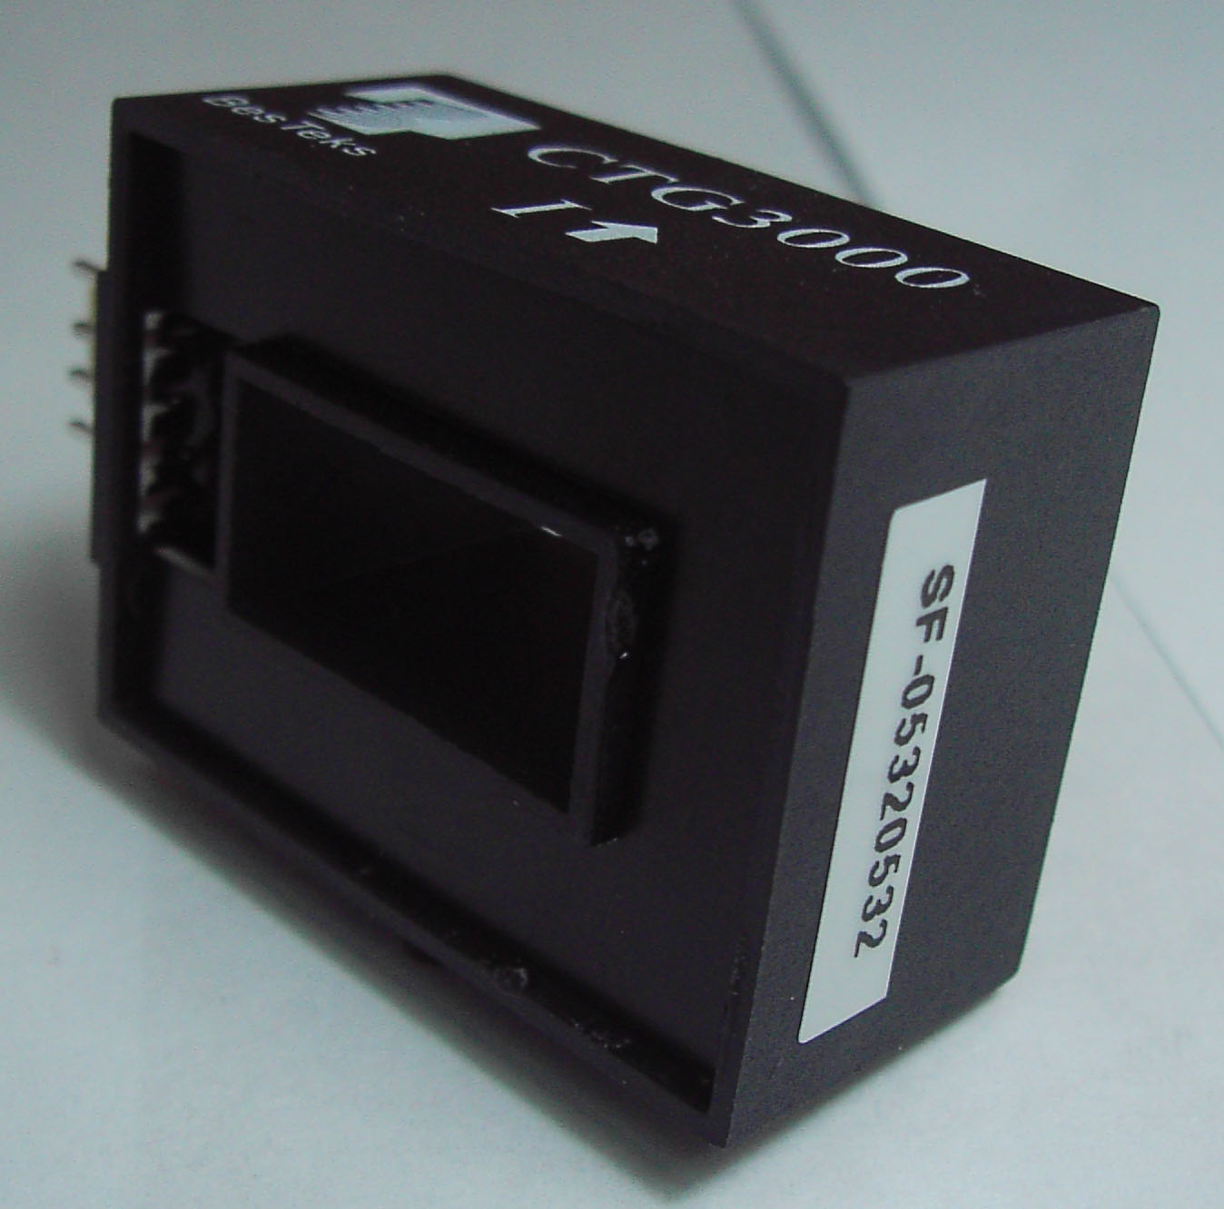 | 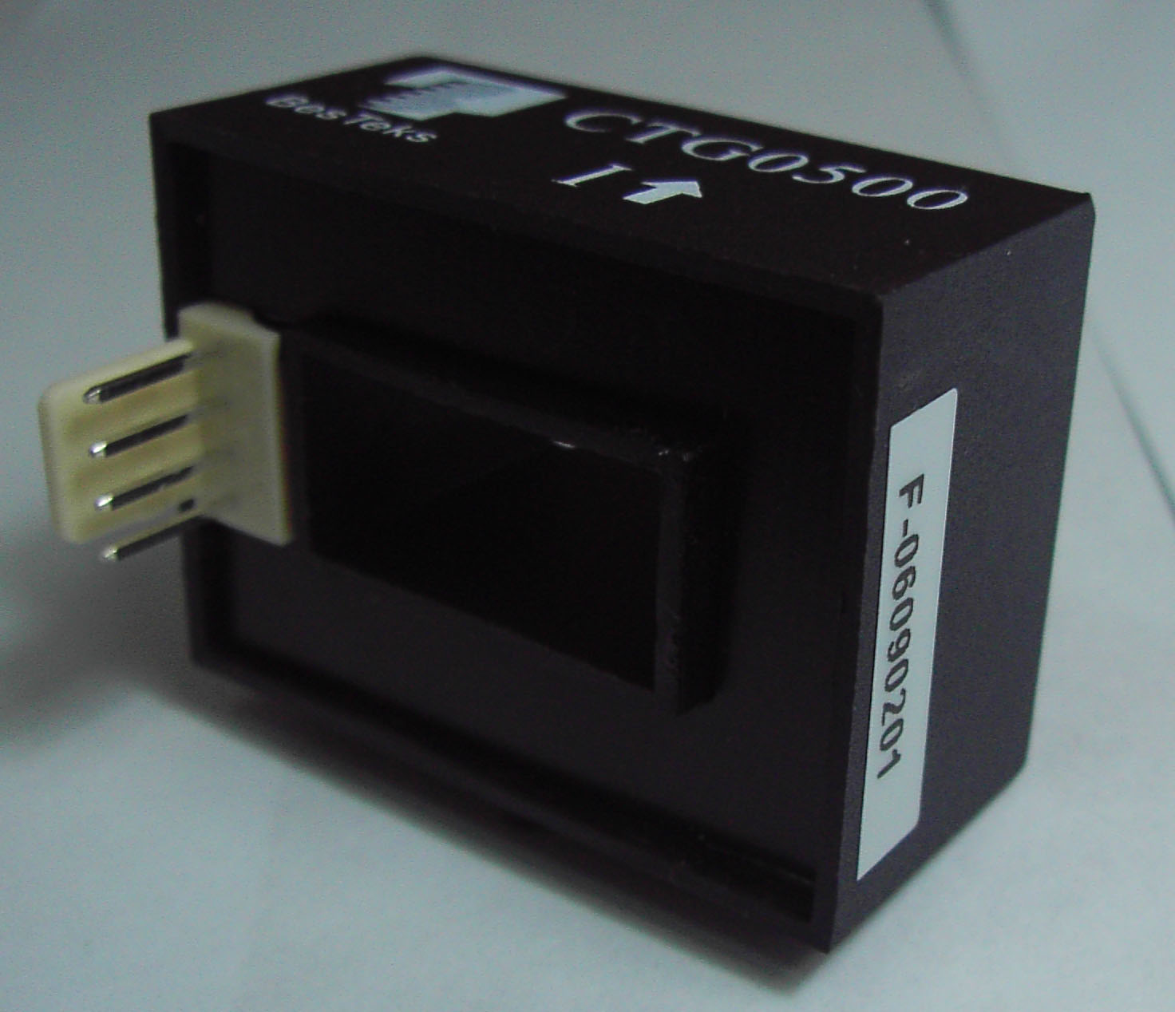
Rated Current | ±(3A ~ 50A) |  |  | ±(50 ~ 600A)
Measure Range | ±150A |  |  | ±900A
Dimension(W*H*D) | 33*23*13 | 16*23*17 |  | 40*28*28
Supply voltage | ±15V(±5%)
Current consume | <±20mA
V0 offset(0 A) | <0±40mV
Vo (at I rated) | V0±4V
Vo linearity | <1%
Thermal drift | <2mV/℃
Output internal R | <100ohms
Load resistance | 10Kohms(suggest)
AC isolation | Min. 2.5KV
Isolated Resis. | >500Mohms(at 500Vdc)
Response time | <3uS(at 90% of Irated*3)
Operate Temp. | -10℃ ~ +80℃
Storage Temp. | -25℃ ~ +85℃
Working Freq. | 50KHz
Remarks | Open loop
Part Name | CTGXXXX-B | CTHXXXX | CTIXXXX | CTLXXXX | CTMXXXX
Out line | 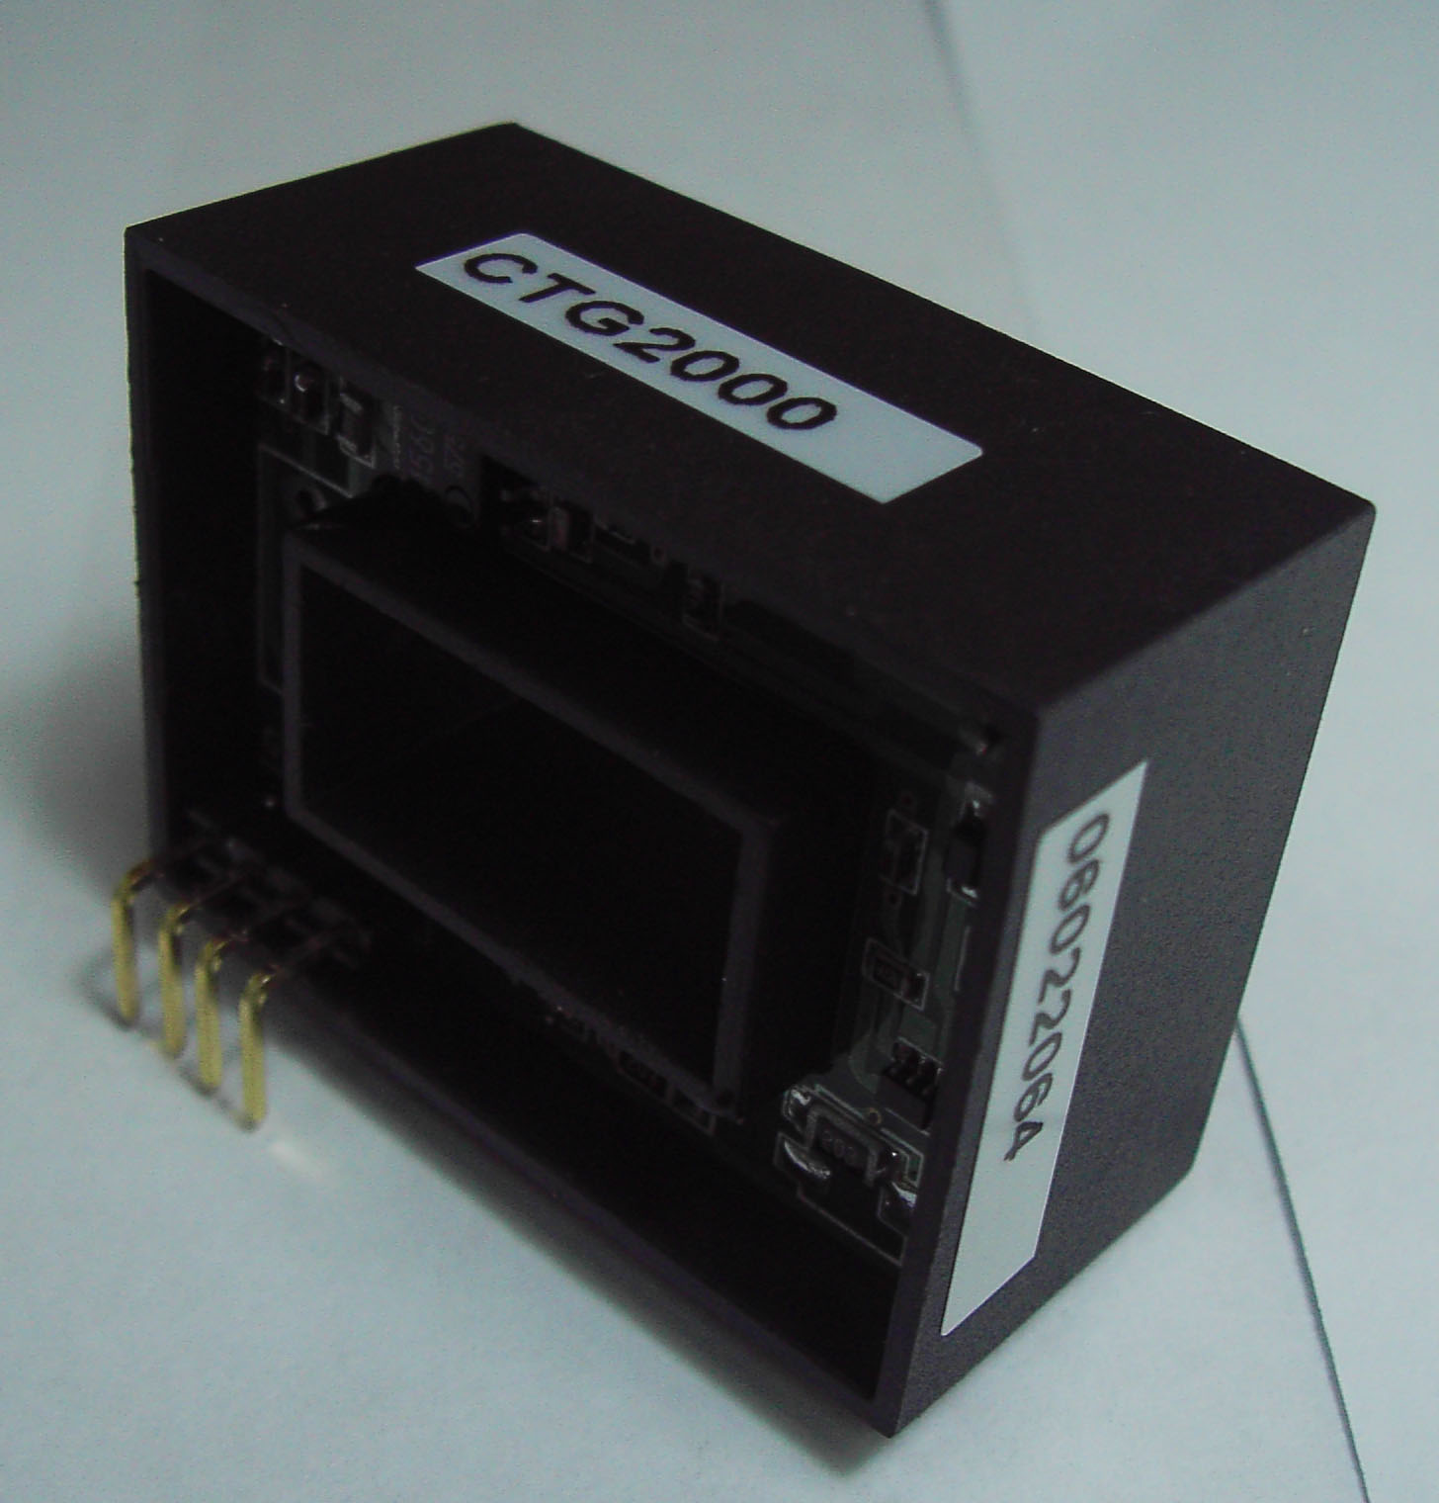 | 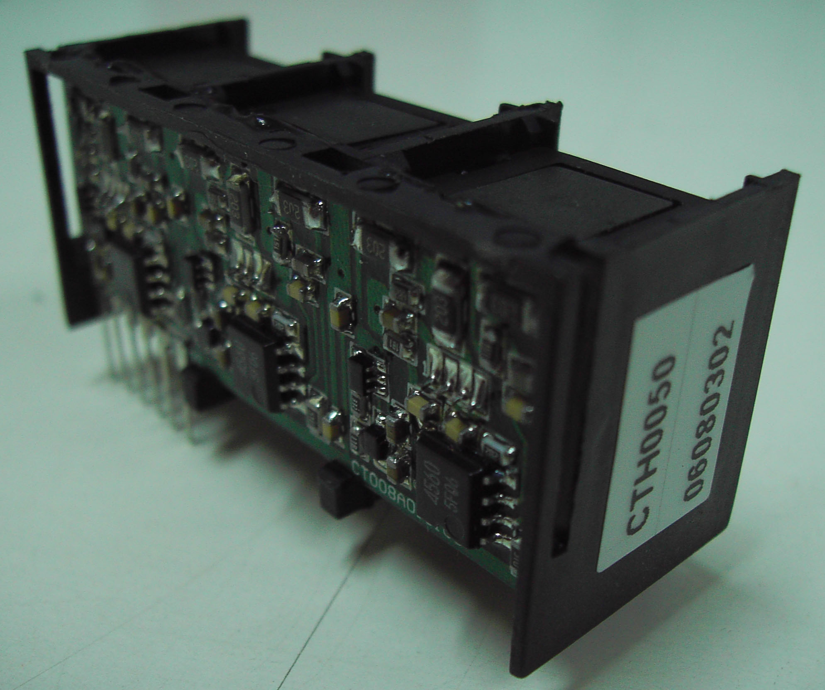 | 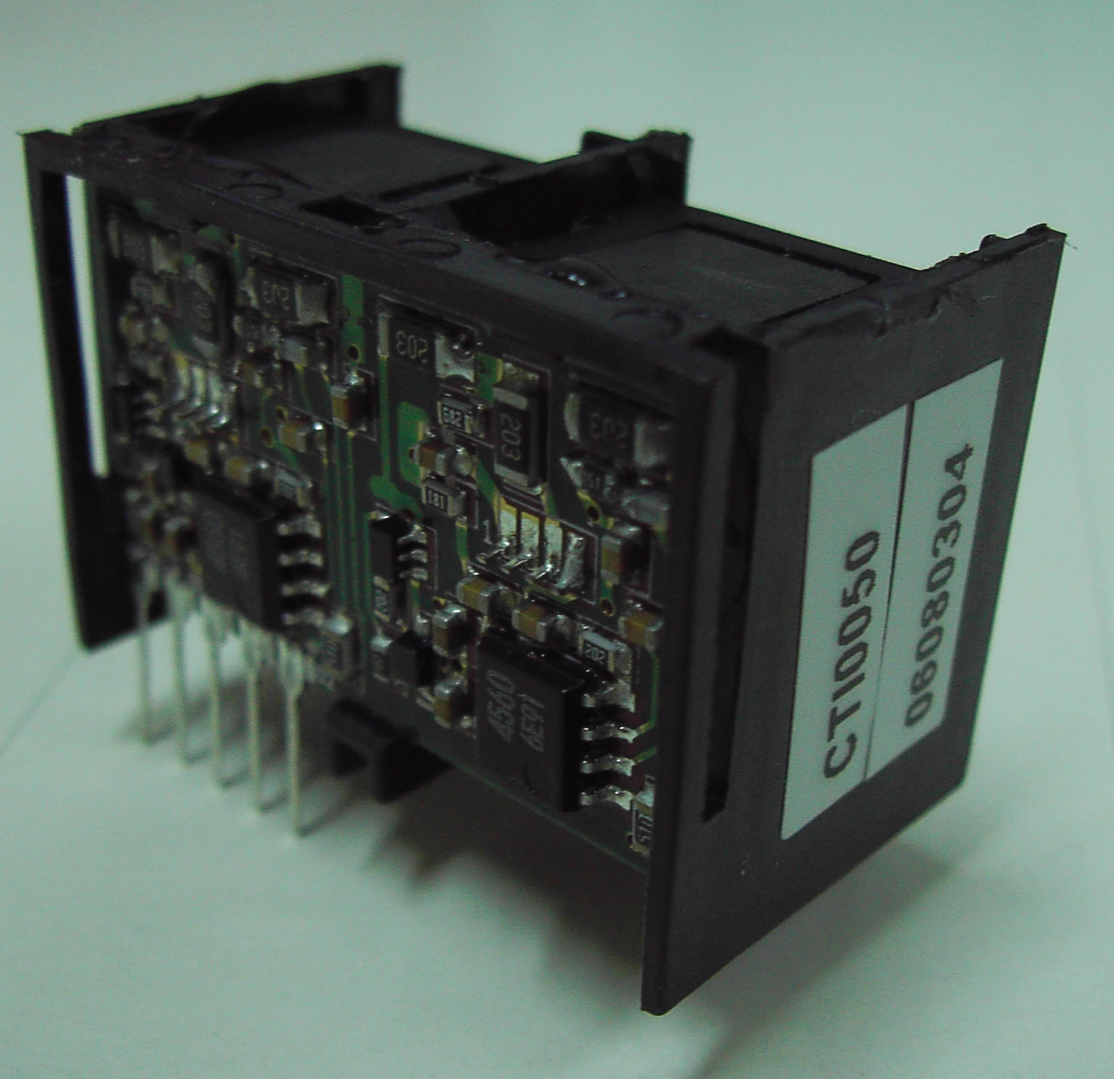 | 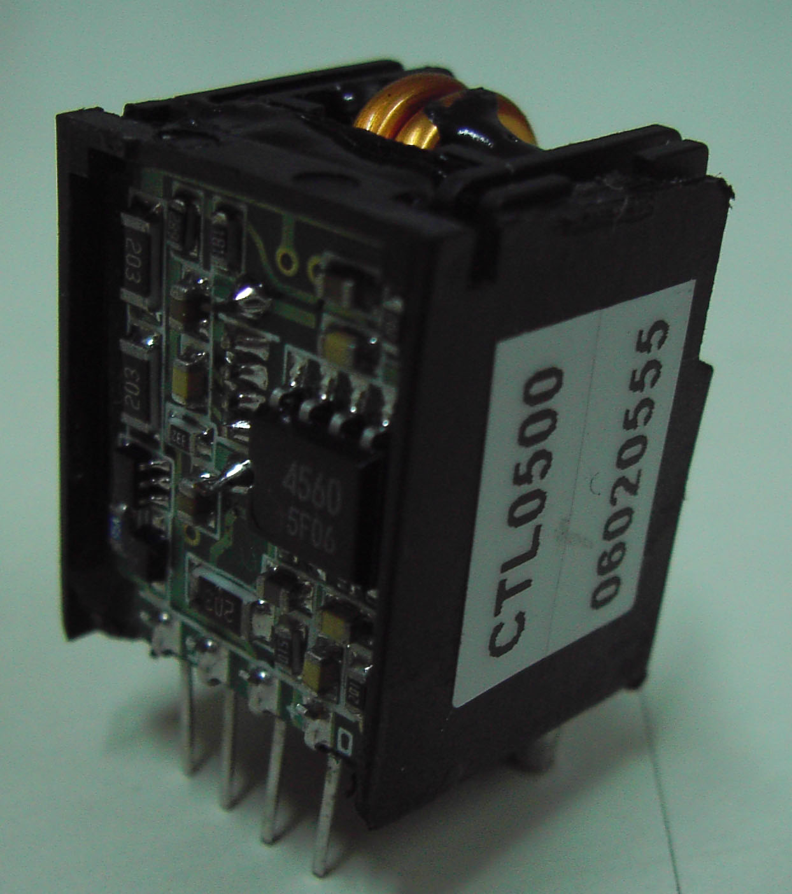 | 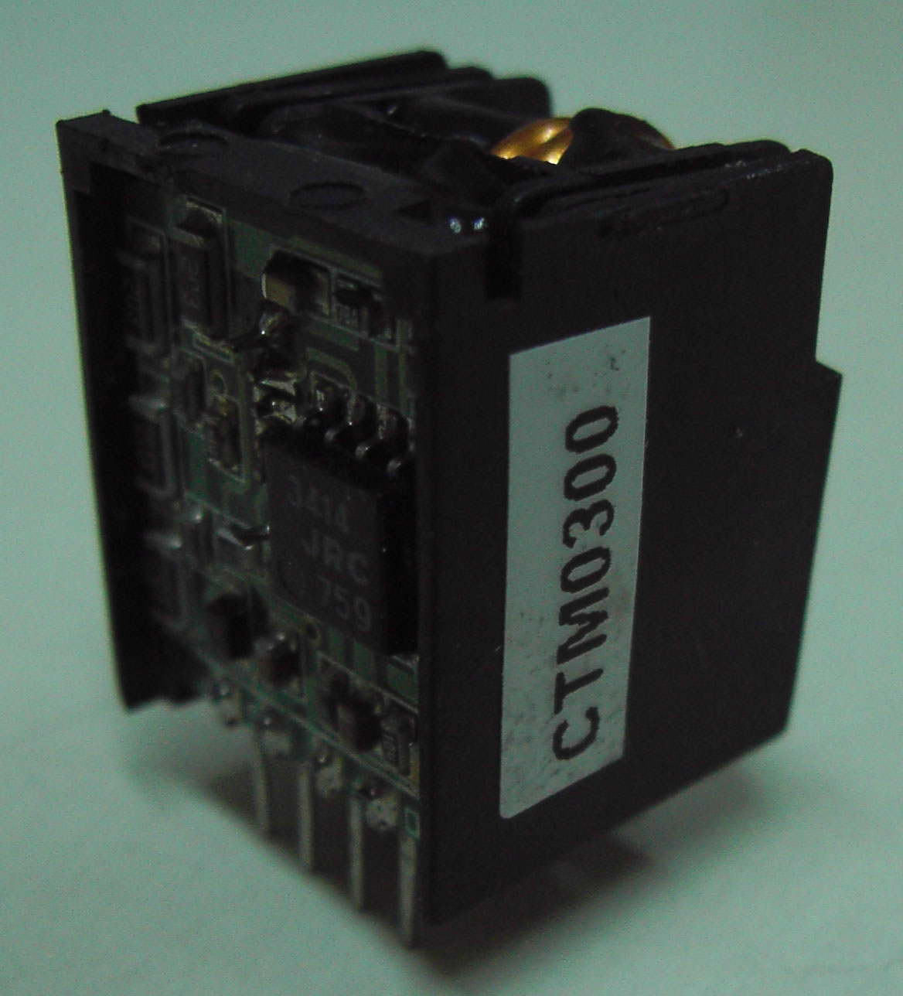
Rated Current | ±(50A ~ 600A) | ±(3A ~ 50A)
Measure Range | ±900A | ±150A |  |  | -50A,+150A
Dimension(W*H*D) | 40*28*28 | 51*21*19 | 34*21*19 | 17*21*17
Supply voltage | ±15V(±5%) |  |  |  | +15V(±5%)
Current consume | <±20mA |  |  |  | <+20mA
V0 offset(0 A) | <0±40mV |  |  |  | <2500±50mV
Vo (at I rated) | V0±4V |  |  |  | V0±2V
Output linearity | <1%
Thermal drift | <2mV/℃
Output internal R | <100ohms
Load resistance | 10Kohms(suggest)
AC isolation | Min. 2.5KV
Isolated Resis. | >500Mohms(at 500Vdc)
Response time | <3uS(at 90% of Irated*3) |  |  |  | <5uS(at Irated)
Operate Temp. | -10℃ ~ +80℃ | -10℃ ~ +85℃
Storage Temp. | -25℃ ~ +85℃
Working Freq. | 50KHz
Remarks | Open loop

